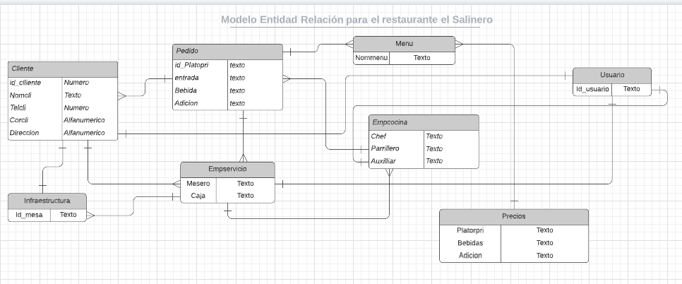

https://lucid.app/lucidchart/41fe5f30-fb19-4fad-9f9e-eaf15c265f7a/edit?viewport_loc=-182%2C-115%2C2384%2C934%2C0_0&invitationId=inv_8146d870-823c-4013-93b0-4fbdca887458